**Hosting Product-Orders as API APP**

1. Repository Link for Code- <https://github.com/handaanmol/order-service>

Go to this repository and you can see the code for Product-orders and you can clone it and run it on your local as the steps are shown in the Readme file on Github only.

1. Now, after this open the Azure Portal, login , click on + Button on left nav bar and search for **API APP** and click on it

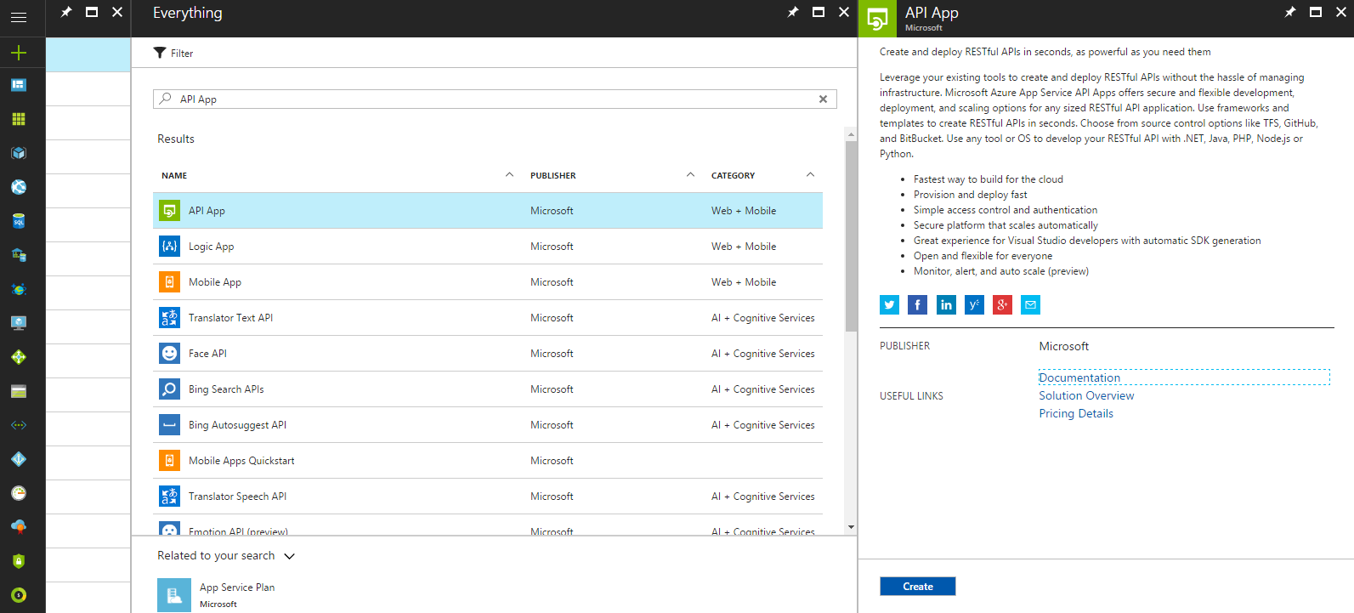

1. Click on create on lower right side, and fill the details like shown below and click on create

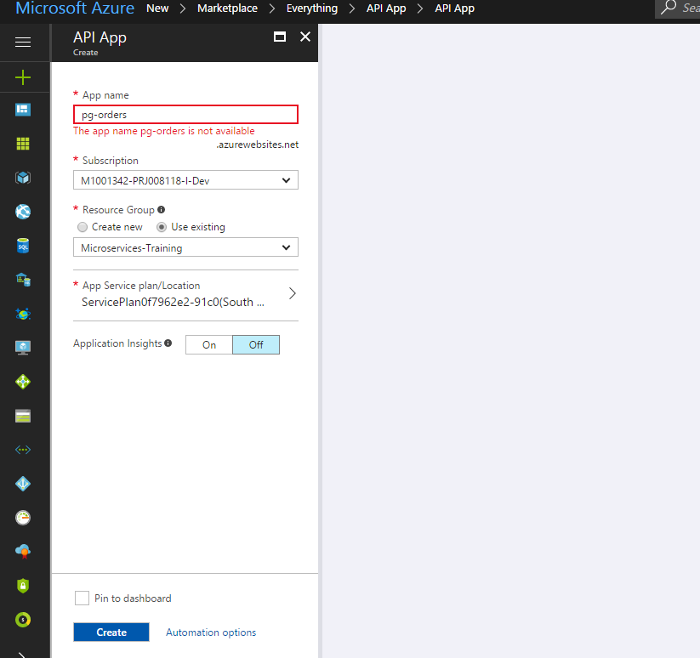

1. Now add Repository to this API APP so that It can do Continuous Integration and give us the latest services by going on the deployment options and following the steps below:

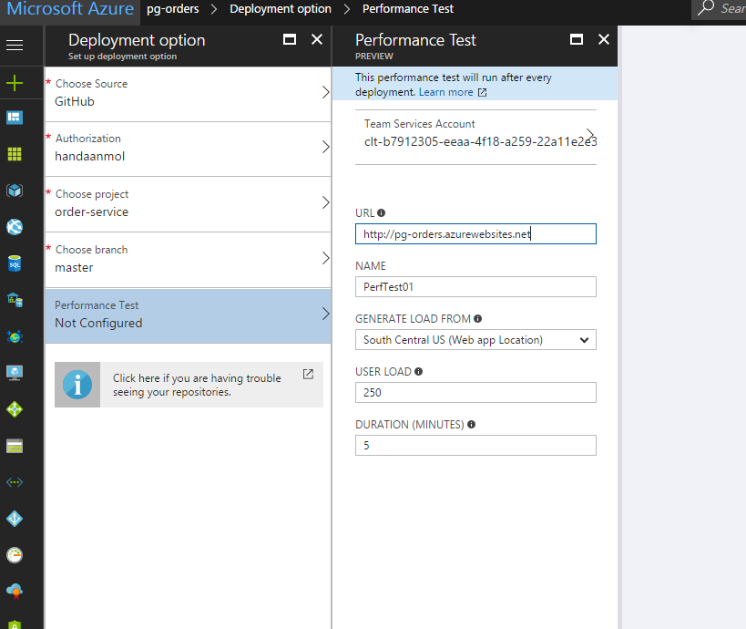

1. Once its created , you go to App services and left navigation bar and you can see your API app present there as shown below

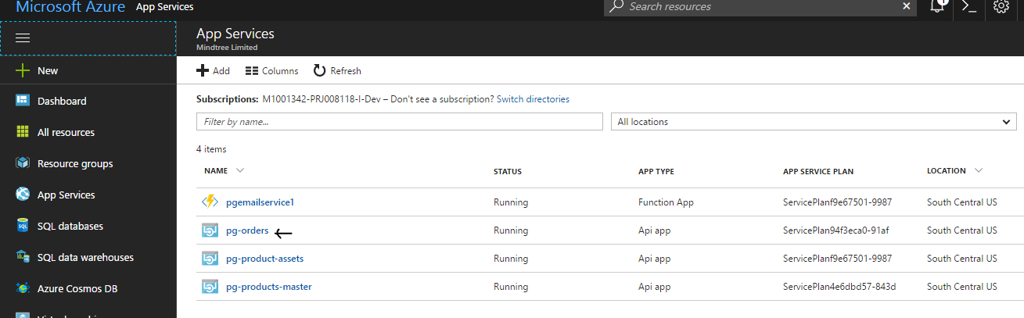

1. Now search for API Management Services in Search Bar and it will show you this



Click on the API Management services

1. Now select pgecommerce from there and click on APIs- Preview there as shown below

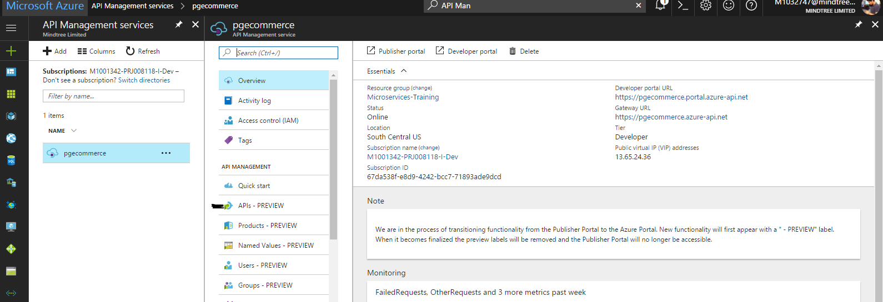

1. Once you are directed to APIs Preview Page , click on API APP as show in screenshot below

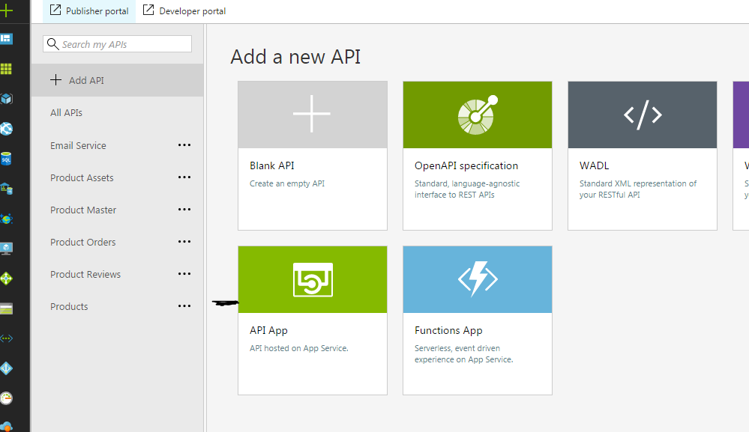

1. It will ask you to create from API APP, browse and select the **pg-orders** API APP which we created as shown below

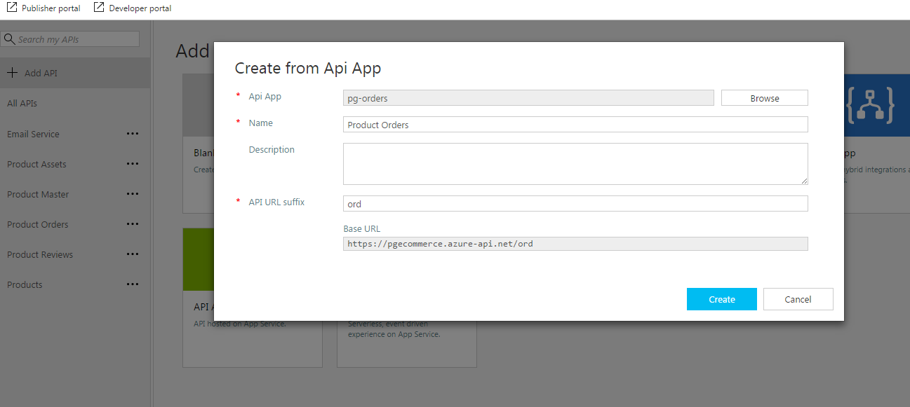

1. Once you create it, you can see your api in the list with name given by you that is Product Orders as show below and then click on it

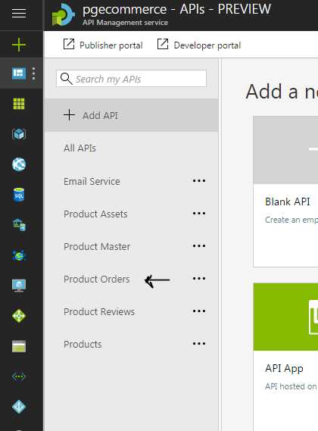

1. Click on add operations and add the operations you need for the API and configure them as per your requirements as show below

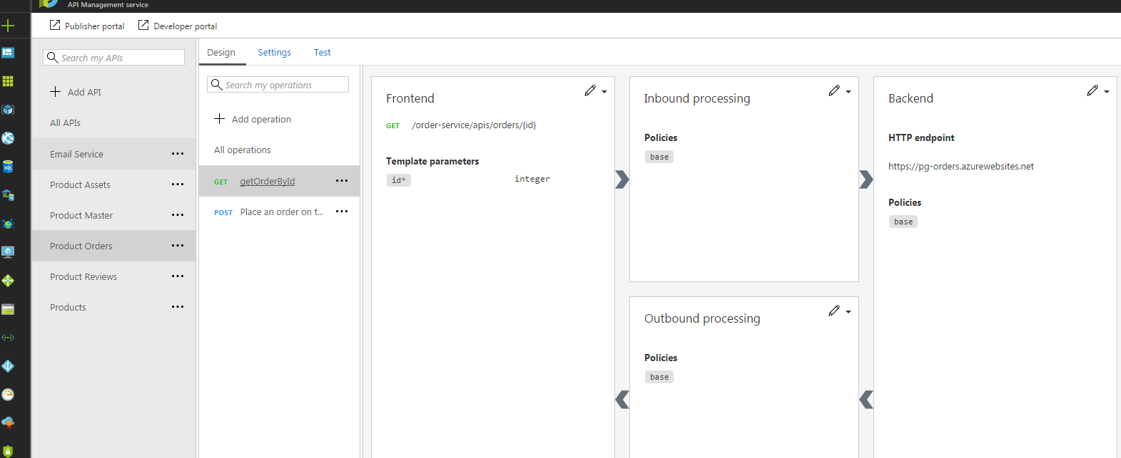

1. Don’t forget to add the API to product named Free trial so that it can use your subscription key for authorization while making API calls. Just API Management Service, select pgecommerce and follow the steps shown in the image

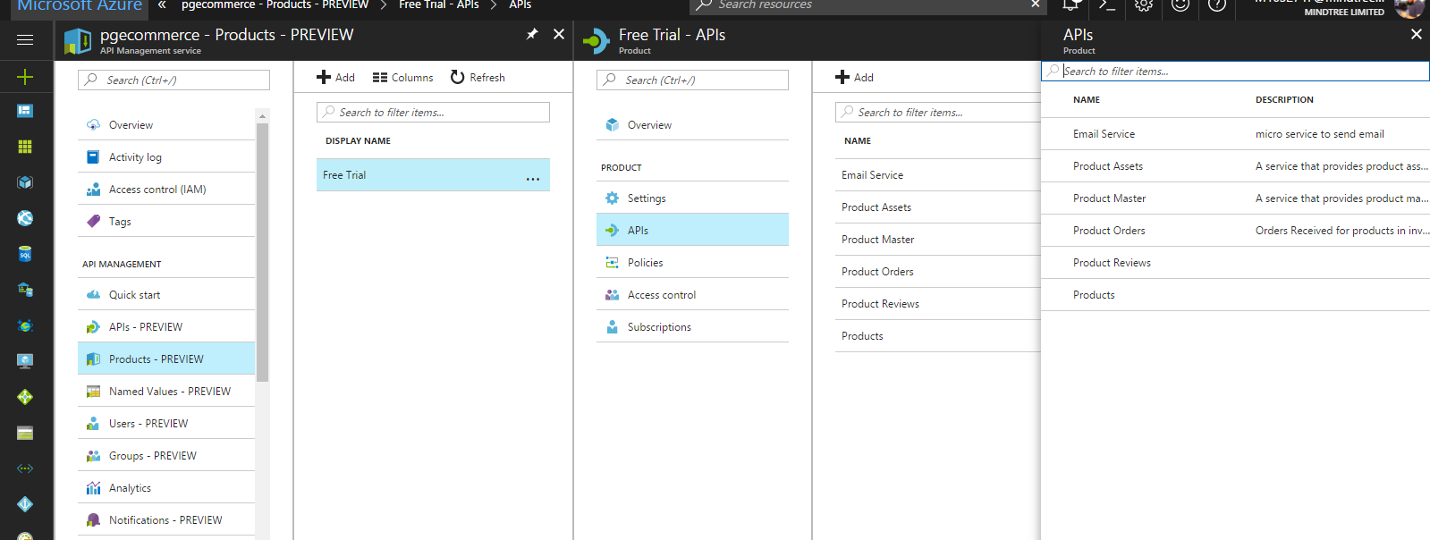

1. You can access these APIs at this link :

[https://pgecommerce.azure-api.net/ord/orders/{id}](https://pgecommerce.azure-api.net/ord/orders/%7bid%7d) – getOrderByOrderId

<https://pgecommerce.azure-api.net/ord/orders> - getAllOrders

<https://pgecommerce.azure-api.net/ord/orders> - PostOrder with JSON like this

{“gtin”: 47400656123, “orderQuantity”:20}